Introduction
Langerhans Cell Histiocytosis (LCH) is a rare blood disorder characterized by the abnormal proliferation and development of Langerhans Cells within the body (Badalian et al.). Similar to cancer, these abnormal Langerhans Cells (LCs) accumulate in cellularly diverse tumor sites, potentially affecting bones, lymph nodes, and entire organ systems if left untreated (Badalian et al.). Affecting only 1 in every 200,000 children, very little is known about the cause of this life-threatening disease.
Regular Langerhans Cells are dendritic cells found primarily in the skin, involved in the immunoregulatory process by presenting antigens to T cells (Valladeu et al.). The LCs involved in LCH are phenotypically similar to regular LCs, but have several behaviors distinct from their healthy counterparts (da Costa et al.). On top of producing the typical LC protein of langerin, LCH cells produce unusually high levels of a range of cytokines, including pro-inflammatory cytokines interleukin-1α (IL-1α) and interferon-γ (IFN-γ), as well as anti-inflammatory IL-10 and growth factor GM-CSF (da Costa et al.).
This unusual behavior may be accounted for through the dysregulation of NF-κB (nuclear factor kappa-light-chain-enhancer of activated B cells) activity (Madonna et al.). A similar mutation in the BRAF V600E gene has been discovered to widely occur in both melanoma and LCH patients, affecting the signaling cascade associated with the pathway (Badalian-Very). NF-κB is a protein complex responsible for regulating DNA transcription within animal cells (Hoesel & Schmid). Documented over-activity in this cell-signaling pathway may be responsible for the overproduction of cytokines and the over proliferation of LCs characteristic of the disease. The root cause of this dysregulation in LCH cells is unknown.
Overall, the pathogenesis of the abnormal LCs in LCH is poorly understood, disallowing for greater understanding of the cellular conditions that result in the neoplasmic (tumorous) behavior of this disease (Rizzo et al.). Regular LCs are typically self-dividing, but the body replenishes LCs after severe damage from bone marrow-derived cellular precursors (Geissmann et al.). Regular LC-like cells have been developed in vitro through exposing adult monocyte CD14+ growth conditions subjected to TGFβ1 (cell growth factor stimulating cell cycle), GM-CSF (general growth factor), and IL-4 (cytokine associated with differentiation of helper T-cells9) (Geissmann et al.). Can LCH-like cells in vitro be derived from similar cell differentiation conditions as regular LC-like cells? Based on this, is there an assumed difference in monocyte CD14+ at the lesion site within LCH-affected patients when compared to non-affected patients? If so, there is indication that LCH may in fact be rooted in myeloid conditions for the production of monoblasts, classifying it as an autoimmune disorder characterized by errors in DNA replication. This finding would further support the theory of regular LC differentiation through CD14+ monocytes, having further application in the realm of research for autoimmune disorders.
Methods
In order to test this particular theory, LCH-afflicted and regular blood samples would need to be collected. Samples would be taken from the lesion site of an LCH patient, preliminary blood from the same patient, and a third sample from a healthy patient who does not have LCH. CD14+ monocytes would be collected through antigen tagging and centrifugation techniques described by Geissmann et al. All samples would be exposed to the same growth conditions defined in the same experiment.
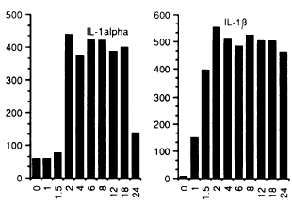
Several molecular markers of LCH-like behavior will be measured. The production of the “cytokine storm” typical in LCH lesions acts as one such marker (da Costa et al.). In order to gauge the actual presence and production of cytokines IL-1α, IFN-γ, IL-10, and GM-CSF, antigen tagging can be utilized to isolate the target proteins, and the presence of RNA encoding these particular proteins will also be measured (Enk & Katz).
Within an experiment conducted by Enk & Katz, the concentration of several RNA precursors for target cytokines involved in the allergic process were measured (Enk & Katz). Similar techniques can be utilized for this experiment. A separate cell sample can be taken from all three prepared differentiated monocyte samples. Pre-produced RNA primers will be added to the samples in order to isolate the desired RNA strands encoding the target cytokines, and other cellular products can be degraded. Once isolated via complementary nucleotide bonding, the overall concentration of the RNA in all three samples can be measured.
Figure A. Strength of signal versus hours after hapten application. Based on results found via electrophoresis in an experiment conducted by Enk & Katz.
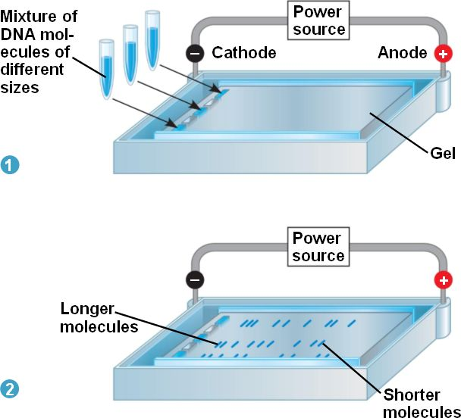
Enk & Katz used Polymerase Chain Reaction (PCR) techniques in order to amplify mRNA levels to a measurable concentration. Complementary DNA was reserve-transcribed from RNA utilizing pre-prepared primers alongside an enzyme known as Moloney murine leukemia virus reverse transcriptase (BRL). The primer sequences for cytokines IL-1α, IFN-γ, IL-10, and GM-CSF have been pre-determined within experiments conducted by Enk & Katz as well as Halminen et al. and Yee et al.
The amplified RNA product of PCR can be measured through liquid hybridization techniques described by Enk & Katz. The amplified RNA products can bind with complementary probes labeled by radioactive isotope Phosphorous-32. The tagged samples can then undergo electrophoresis in order to measure the capacity for dispersion in each sample. The samples can be added to prepared PAGE gel and an electric current can be sent through it in order to disperse the contents across the gel as described in Figure B. Quantitative analysis via software and scanners compare the length of measurement resulting from sample concentrations and generate Phosphorous-32 signal strength comparisons like those found in Figure A. These can be used to compare the cytokine concentrations within our three samples.
Figure B. Electrophoresis of amplified RNA products will be performed on Phosphorous-32 and non- Phosphorous-32 labeled samples. With an electric current added, DNA moves towards the negatively charged end of the gel. Image provided via Pearson Biology Online.
Of additional interest are markers indicating unusual NF-κB activity within the cells. There are several steps involved in this signaling pathway, but specific measurements for the sake of this experiment will involve measuring the phosphorylation of p65 as well as the subsequent production of p50, two proteins involved in the cascade (Hoesel B & Schmid). There are several enzyme-linked immunosorbent assay (ELISA) kits available and widely utilized to test these processes; however, they all follow a similar technique (Hayworth). ELISA of p65 and p50 involves isolating those desired antigens and obtaining antibodies specified for those antigens, provided within the kits. Antibodies attach to the antigens when immobilized within a well, and a second labeling antibody attaches to the complex. This label contains a dye that emits color when bound, indicating the presence of the desired protein.
Discussion
The first question that will be uncovered within this experiment is whether or not the monocyte-dependent differentiation pathway theorized for regular LCs is even relevant in abnormal LCH cells. That is, is it possible for LCH cells to be derived from the exact same conditions as LCs in vitro? In the event that they are not, then one possible origin for regular or irregular LCs can be ruled out. Further experimentation for other proposed LC differentiation origins via different monocytes can be tested using the same procedures described in this experiment, potentially suggesting the in vivo origin of regular LCs. Otherwise, it can be assumed there are no differences within the monocyte precursors in LCH cells, indicating non-myeloid environmental causes for the development of the disease.
Further data might be drawn as it pertains to the differentiation of regular LCs as a result of this experiment. If LCH-like cells are derived from like conditions, then this further suggests the monocyte CD14+ is involved in initial production of LCs. This has application within the field of autoimmune research; LCs are involved in the body’s first response to HIV and other like viruses, and knowledge of how to replenish the body’s supply might help in treatment of the disease.
If LCH-like cells can be derived from these particular monocytes, then genomic differences in monocytes within the lesion site are likely accountable for this altered differentiation pattern. DNA sequencing of both monocyte samples from the lesion and preliminary blood of the LCH patient could be pursued to document these differences. Fearon & Vogelstein conducted a similar study with colon cells from tumor and nontumorous sites, identifying potential oncogenes involved in the development of colon cancer (Fearon & Vogelstein). Those techniques might be utilized for this follow-up study.
Increased knowledge about the role of NF-κB activity within LCH cells might help in the development of better treatments against the disease. If unusual NF-κB activity exists, inhibitors used to treat certain cancers might be helpful in the treatment of LCH (Hoesel & Schmid). Additional research can be conducted to determine what cell signals result in abnormal behavior typical of LCH. DNA sequencing as described above would serve as a basis for identifying atypical protein behavior.
References
Badalian-very G, Vergilio JA, Degar BA, Rodriguez-galindo C, Rollins BJ. Recent advances in the understanding of Langerhans cell histiocytosis. Br J Haematol. 2012;156(2):163-72.
Badalian-Very, Gayane et al. “Recurrent BRAF Mutations in Langerhans Cell Histiocytosis.” Blood 116.11 (2010): 1919–1923. PMC.
da Costa, Cristiana E.T., Nicola E. Annels, and R. Maarten Egeler. "The immunological basis of Langerhans cell histiocytosis", Histiocytic Disorders of Children and Adults. Ed. Sheila Weitzman and R. Maarten Egeler. 1st ed. Cambridge: Cambridge University Press, 2005. pp. 66-82. Cambridge Books Online.

Enk, A.H., Katz, S.I.(1992).Early molecular events in the induction phase of contact sensitivity. Proc. Natl. Acad. Sci. USA,89, 1398-1402.

Fearon ER, Vogelstein B. A genetic model for colorectal tumorigenesis. Cell. 1990;61(5):759-67.

Halminen M, Sjöroos M, Mäkelä MJ, et al. Simultaneous detection of IFN-gamma and IL-4 mRNAs using RT-PCR and time-resolved fluorometry. Cytokine. 1999;11(1):87-93.

Hayworth, Douglas. Overview of ELISA. 2014. Web. http://www.piercenet.com/method/overview-elisa

Hoesel B, Schmid JA. The complexity of NF-κB signaling in inflammation and cancer. Mol Cancer. 2013;12:86.

Madonna G, Ullman CD, Gentilcore G, Palmieri G, Ascierto PA. NF-κB as potential target in the treatment of melanoma. J Transl Med. 2012;10:53.

Rizzo FM, Cives M, Simone V, Silvestris F. New insights into the molecular pathogenesis of langerhans cell histiocytosis. Oncologist. 2014;19(2):151-63.
Valladeau, Jenny; Dezutter-Dambuyant, Colette; Saeland, Sem (2003). "Langerin/CD207 Sheds Light on Formation of Birbeck Granules and Their Possible Function in Langerhans Cells". Immunologic Research 28 (2): 93–107.
Yee CS, Yao Y, Xu Q, et al. Enhanced production of IL-10 by dendritic cells deficient in CIITA. J Immunol. 2005;174(3):1222-9.

